SIMATS ENGINEERING
ASSESSMENT TOOL 1
COURSE NAME: INTERNET PROGRAMMING
COURSE CODE: CSA43
COURSE OUTCOME COVERED
CO-1 : Develop well-structured, standards-compliant web pages using HTML/XHTML and XML, and apply Internet protocols and HTTP communication mechanisms for web content delivery. (L2)
Assessment Tool : Application-Based Questions
Weightage: 40%
QUESTIONS: Total Marks: 30

1: Online Symposium Portal
A college is developing an online symposium registration portal. The following HTML structure and HTTP interaction is observed:
<form action="/register" method="POST">
<input type="text" name="name">
<input type="email" name="email">
<button>Submit</button>
</form>
When a student submits the form, the browser sends an HTTP request to the server, and the server responds accordingly. Questions:
- Identify appropriate HTML5 semantic elements missing in the structure.
- Modify the structure to make it standards-compliant.
- Interpret the HTTP request generated during form submission.
- Analyze the HTTP response cycle from server to browser.
- Suggest improvements for usability and accessibility.

2: Cross-Browser Compatibility Issue
A company website shows inconsistent layout across browsers. The following HTML snippet is used:
<html>
<head>
<title>Company</title>
</head>
<body>
<div>
<h1>Welcome
<p>About us
</div>
</body>
</html>
Questions:
- Identify improper nesting and missing closing tags.
- Analyze how different browsers may interpret this structure.
- Identify missing semantic elements (e.g., header, section).
- Provide a corrected W3C-compliant HTML structure.
- Suggest techniques to ensure cross-browser compatibility.

3: Form Submission Failure
A web application fails to send form data to the server. The following configuration is observed:
<form action="/submit" method="GET">
<input type="text" name="username">
<input type="password" name="password">
<button type="button">Login</button>
</form>
Questions:
- Identify issues in the form configuration.
- Analyze why the HTTP request is not triggered.
- Interpret the role of GET method in this scenario.
- Propose a corrected implementation.
- Suggest improvements for secure data transmission.
Code of Conduct:
I __R.Asif__ (Name / Reg No) certify that this submission is my original work and that I have adhered to the guidelines specified for this assessment. I understand that any violation of academic integrity rules will result in disciplinary action.
Signature of the student:R.Asif
Answers 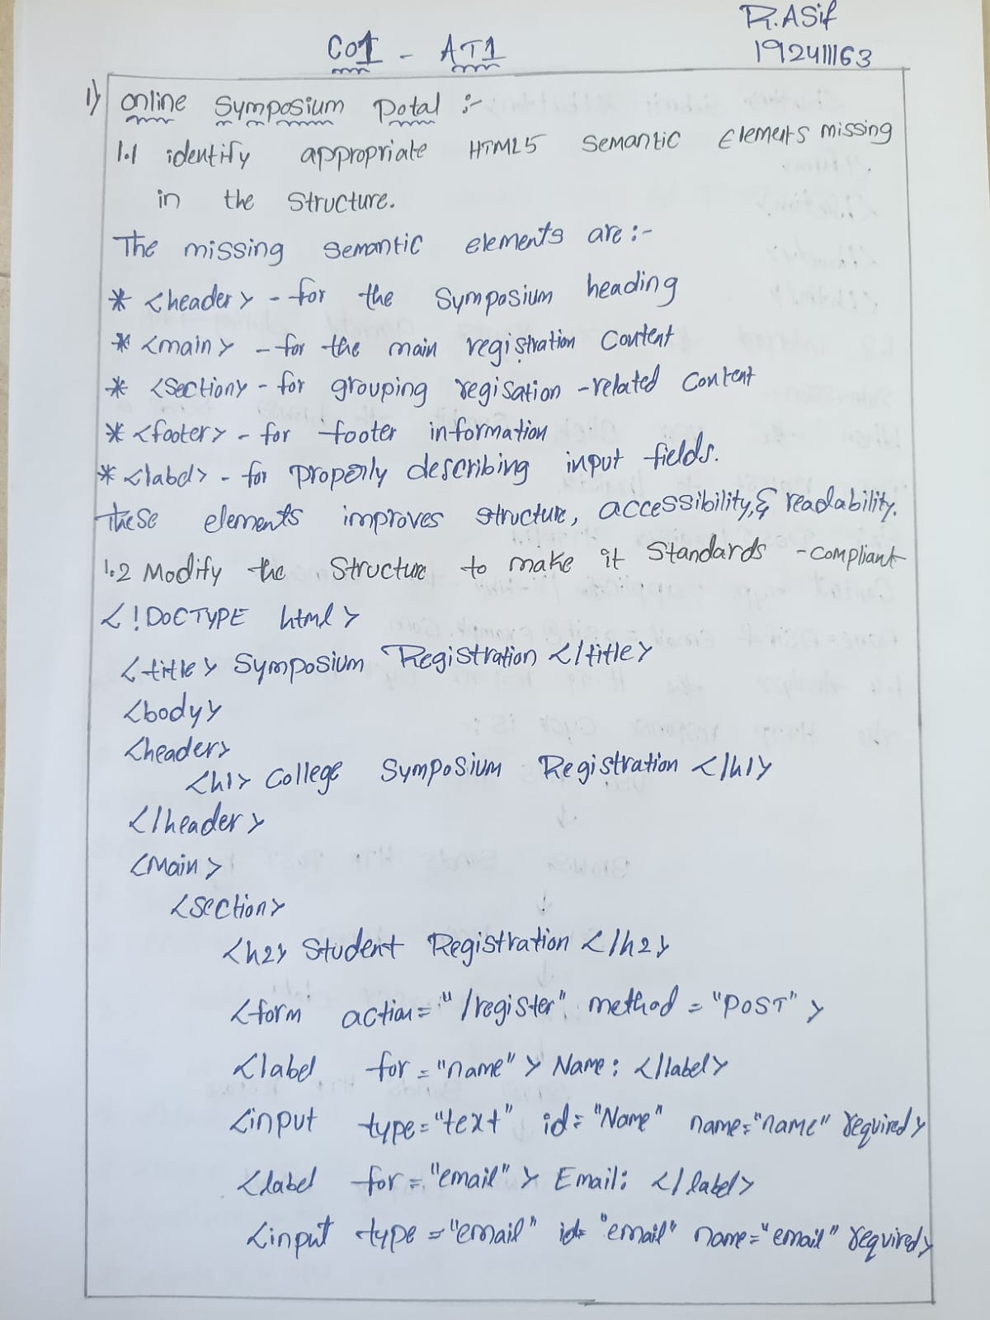
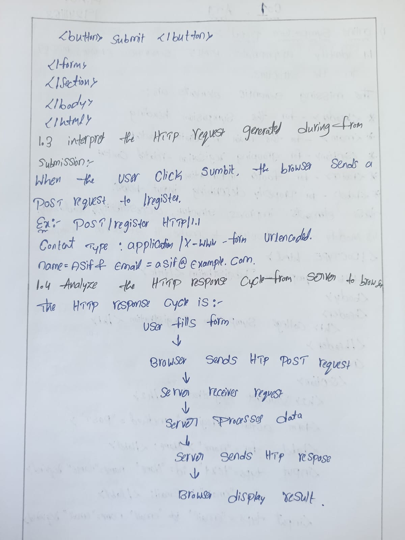

Screenshorts:
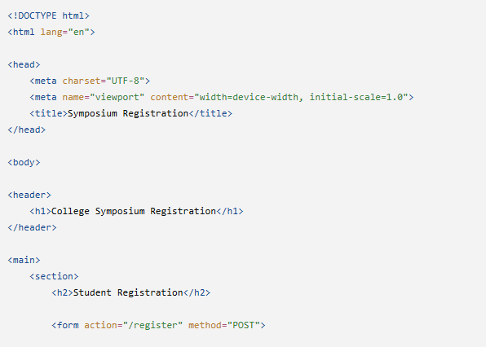
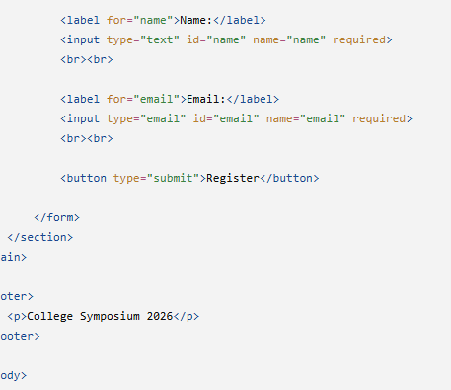
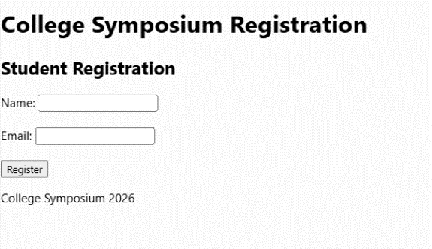
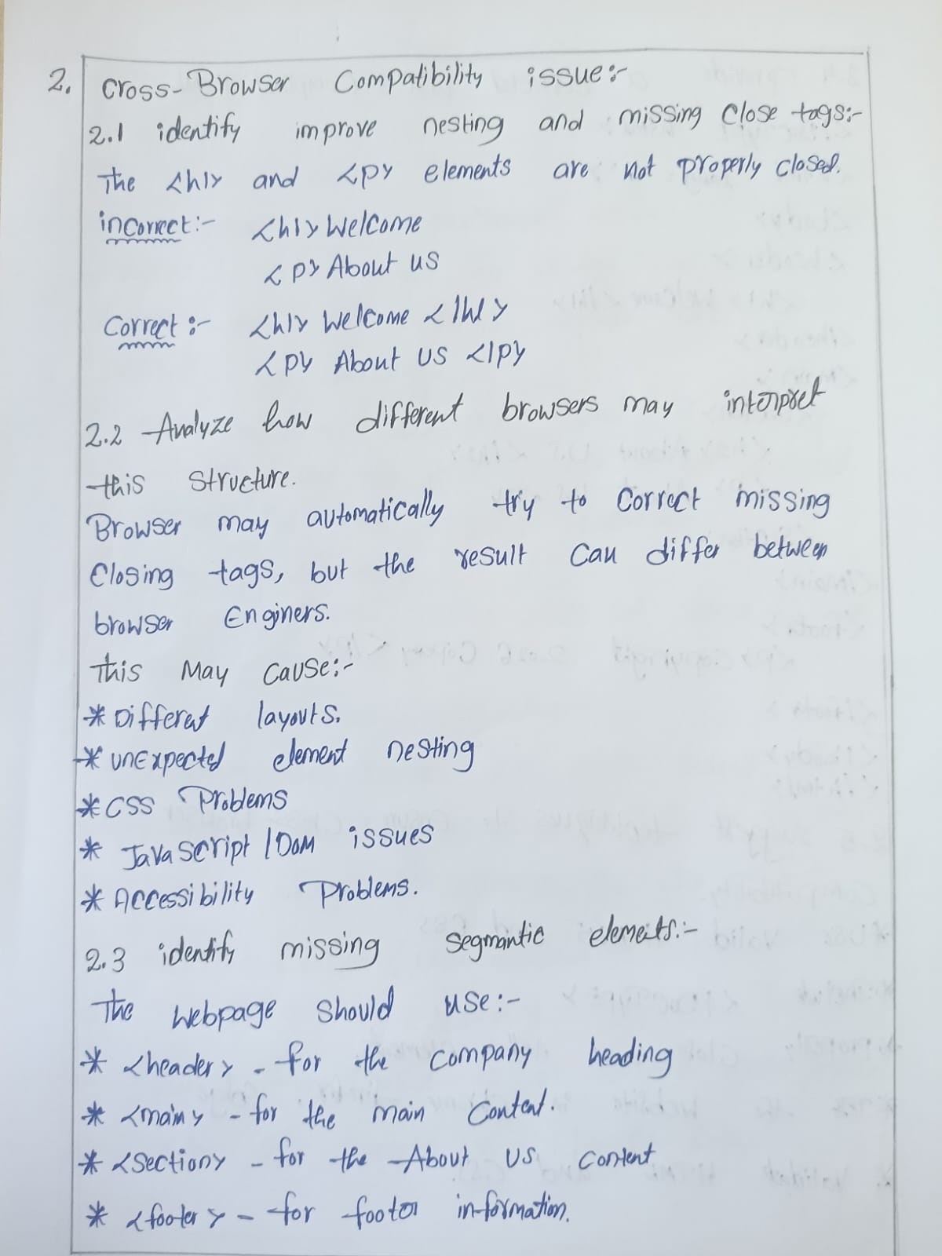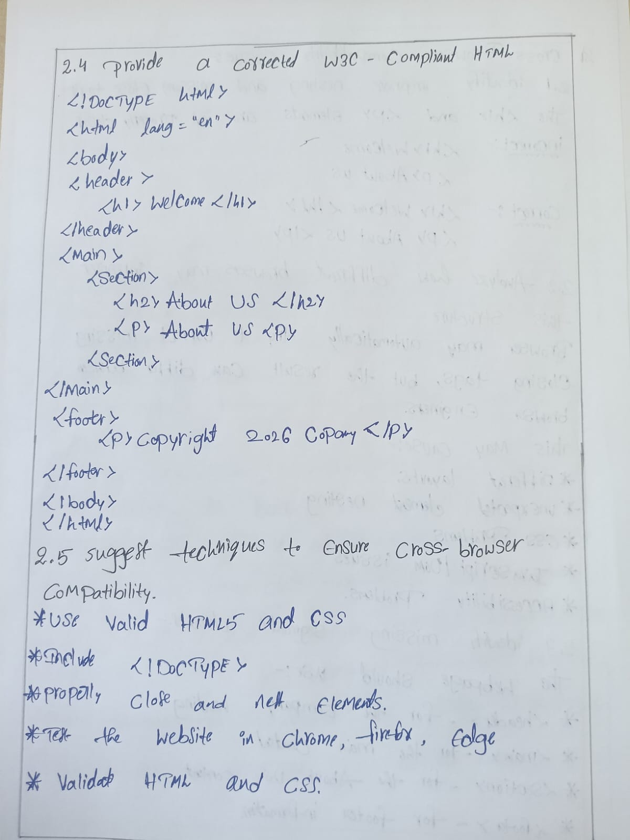

Screenshorts:
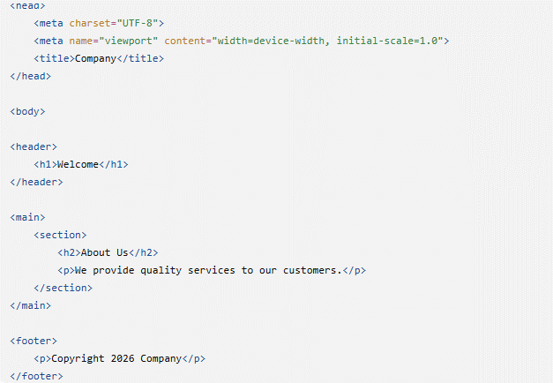
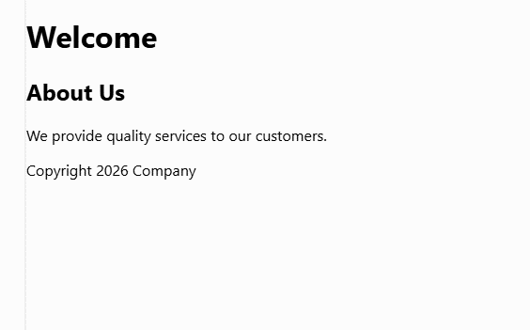Screenshorts:
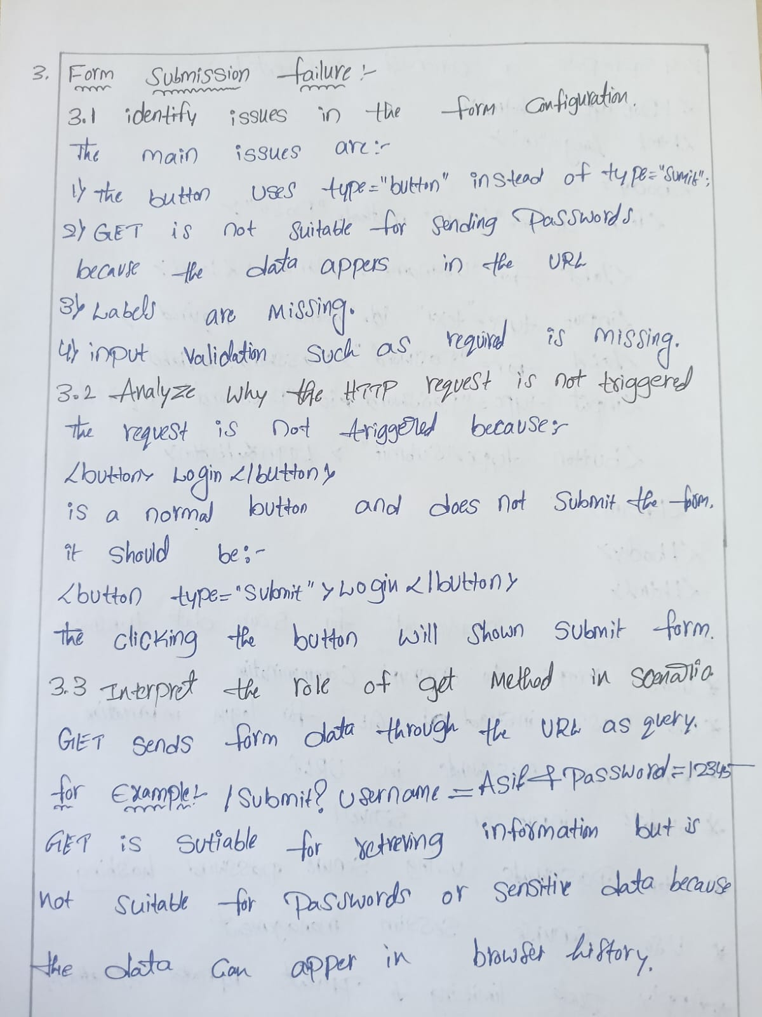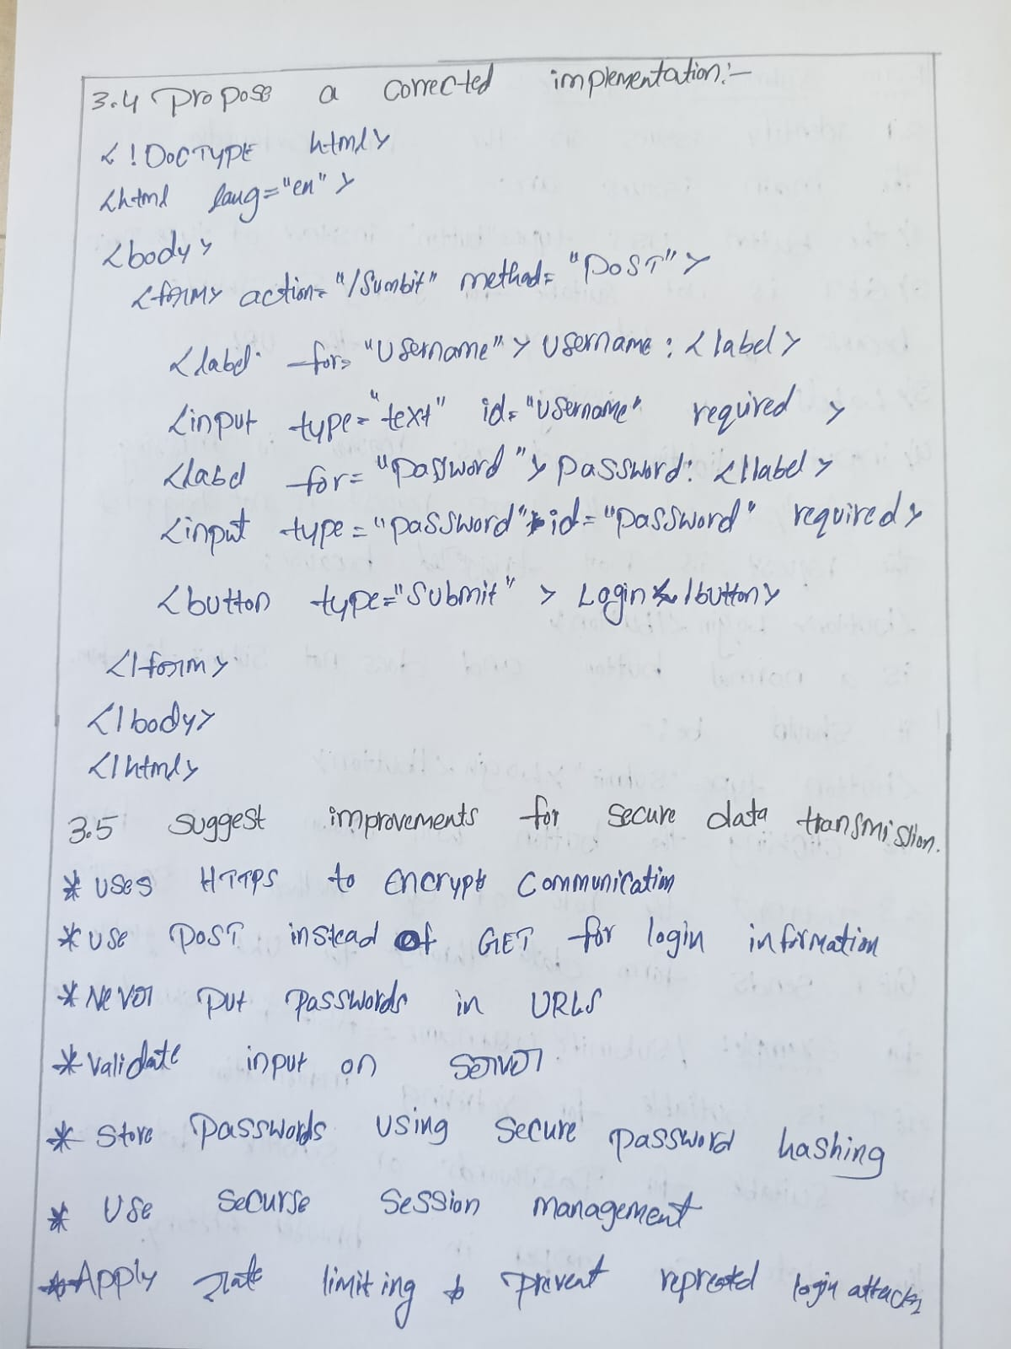
Screenshorts:
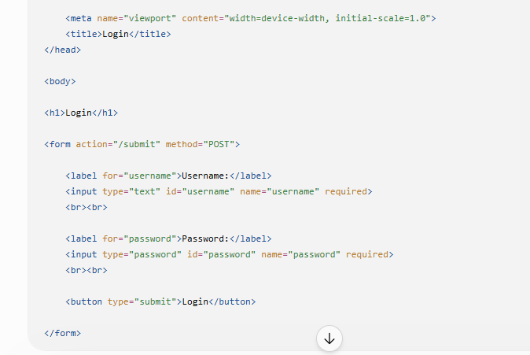
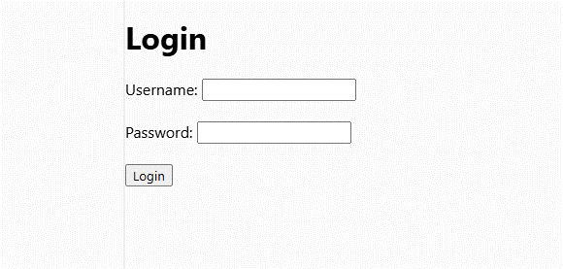

RUBRICS FOR CALCULATION:

Criteria | Weig htage | Level 4 –  Exemplary | Level 3 –  Proficient | Level 2 –  Developing | Level 1 –  Beginning
Understanding of Concepts | 25% | Demonstrates thorough, accurate  understanding of concepts | Good understanding with minor gaps | Basic understanding with some  misconception s | Poor understandin g; major  misconceptio ns
Explanation | 25% | Detailed, wellexplained answers with relevant examples | Clear explanation with adequate  details | Limited explanation; lacks depth | Poor or unclear explanation
Application | 20% | Effectively applies concepts with strong analytical ability | Applies concepts with minor errors | Limited application  with weak analysis | No  application or incorrect analysis
Organization | 15% | Well-structured answers with logical flow and coherence | Organized with minor issues in flow | Basic structure, lacks clarity | Poor organization,  incoherent answers
Accuracy | 10% | Completely accurate and covers all required points | Mostly accurate with minor omissions | Partially correct with missing points | Incorrect answers with major gaps
Clarity | 5% | Clear, neat, professional presentation | Understandable with minor issues | Limited clarity, readability issues | Poorly written,  difficult to understand

